*BUSINESS ANALYTICS*

**Topic: SQL Assignment**

**Name: LYNDA THANKAM VARGHESE**

**Reg No. 2237042**

**Class 1MAECO**

Date of Submission

30/03/2023

**Submitted to**

**Mr. ABDUL RAJA**



MA APPLIED ECONOMICS

DEPARTMENT OF ECONOMICS

CHRIST (DEEMED TO BE UNIVERSITY)

August 2022

1. Use case: To review the crime scene report and gather information about the murder that took place on January 15, 2018, in SQL City.

The goal is to analyze the crime scene report and extract details about the murder incident that occurred on January 15, 2018, in SQL City. We can use the SELECT statement to retrieve all columns from the crime_scene_report table and the WHERE clause to filter the data based on the specified date, type, and city.

SELECT * FROM crime_scene_report

WHERE date = '20180115'

AND type = 'murder'

AND city = 'SQL City'

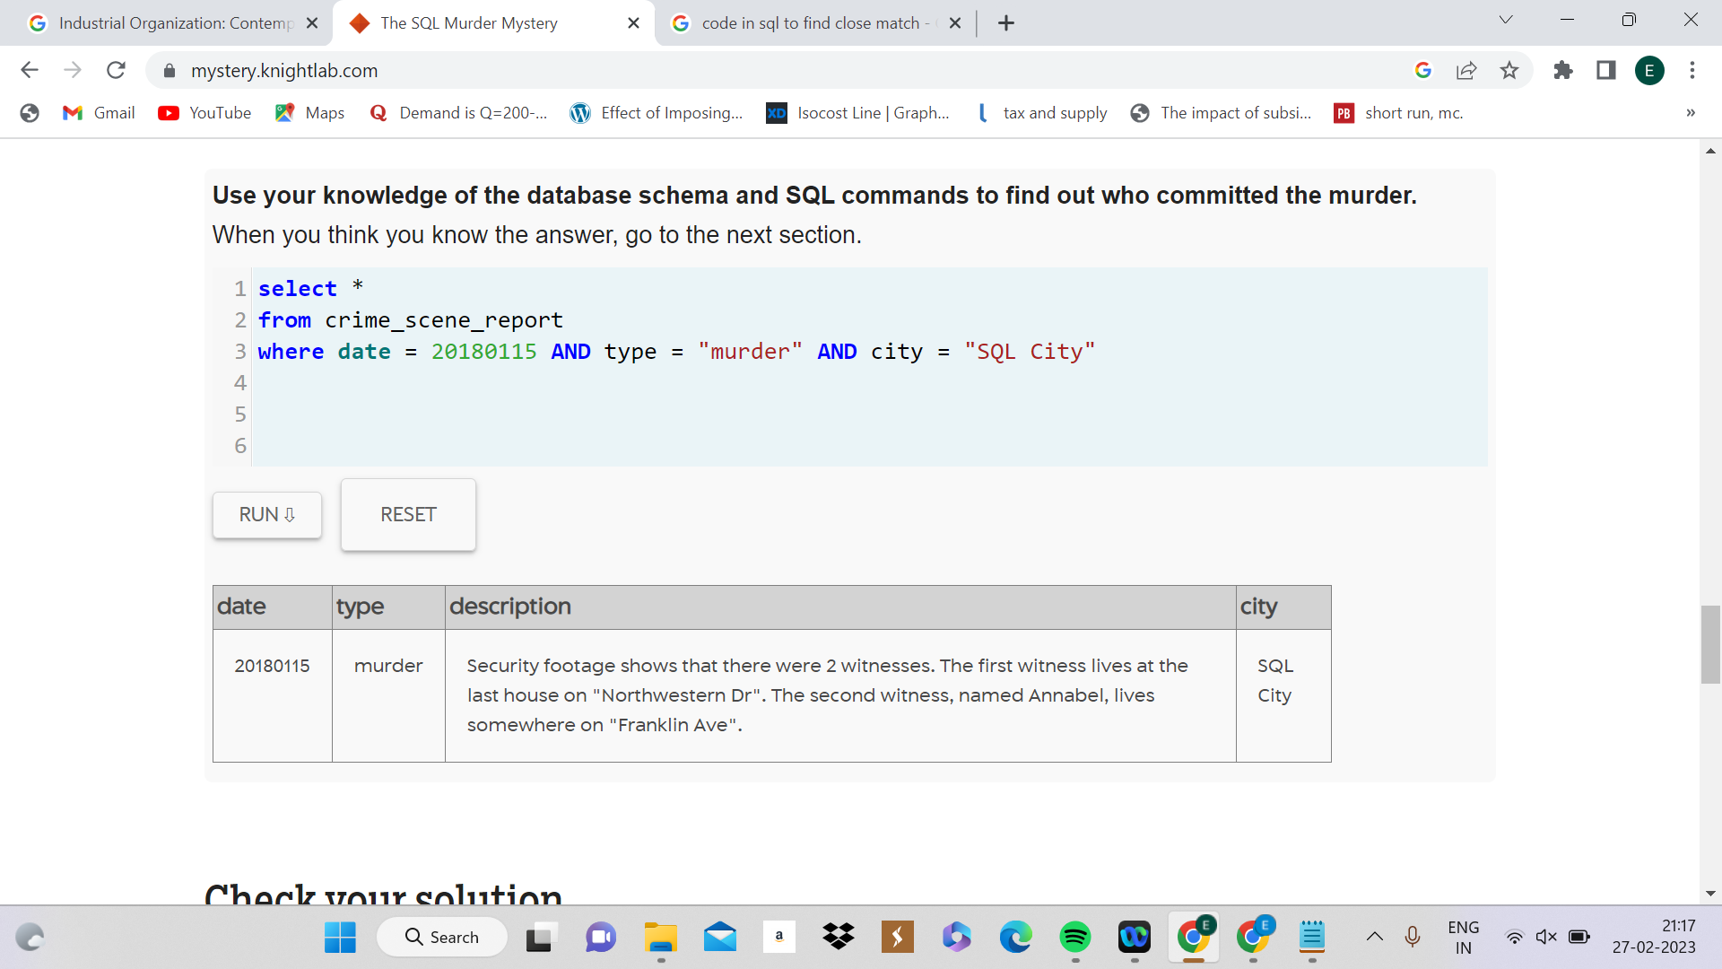

1. Use case - To check all the events happening on 15th January 2018.

SELECT *

FROM event

WHERE start_date = '2018-01-15'

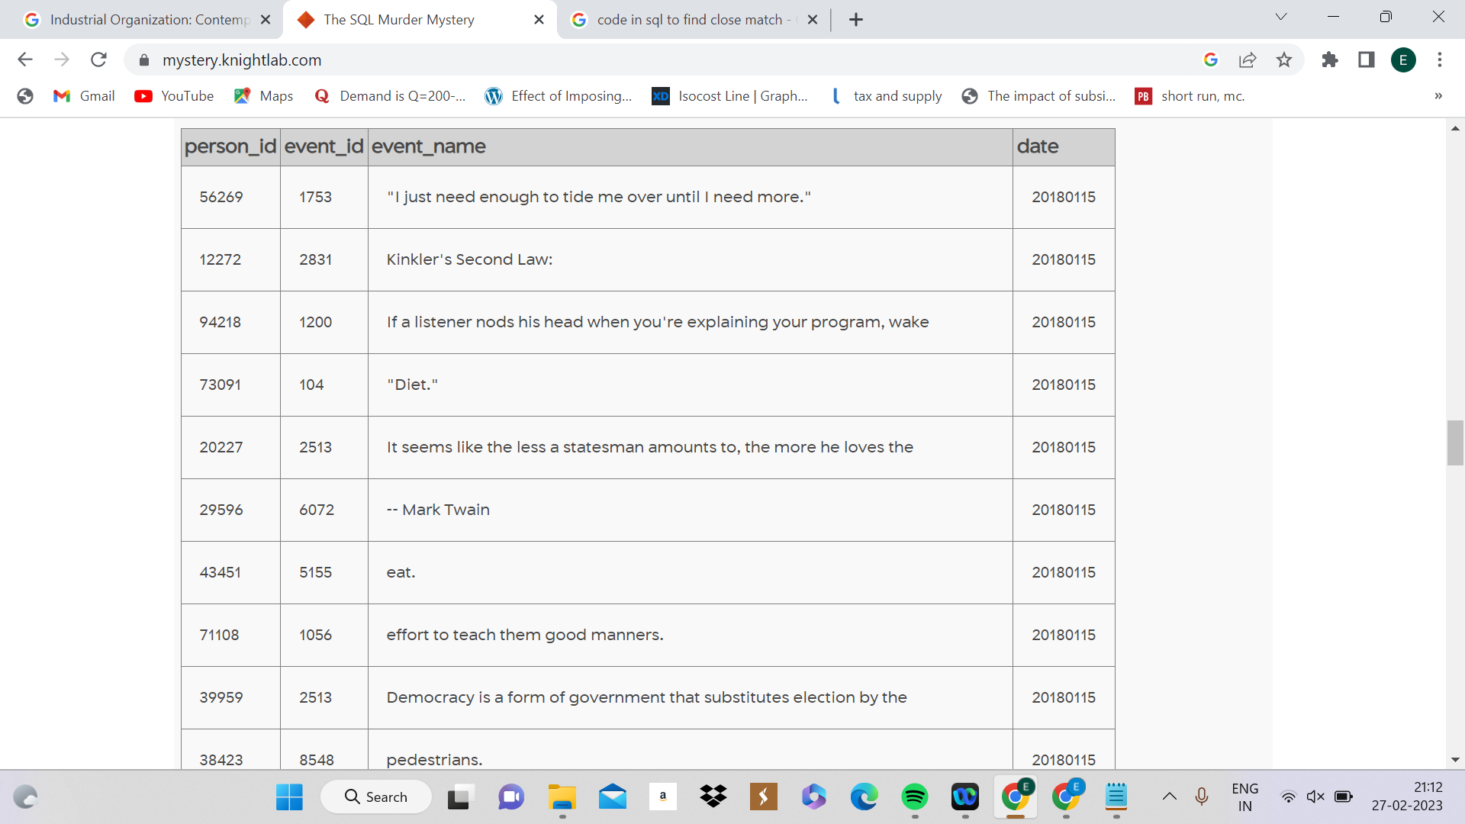

1. Use case - To understand if the murder was in the gym on the 15th of Ja nuary 2018.

SELECT *

FROM gym_check_in

WHERE check_in_date = '2018-01-15' AND location = 'Get Fit Now Gym'

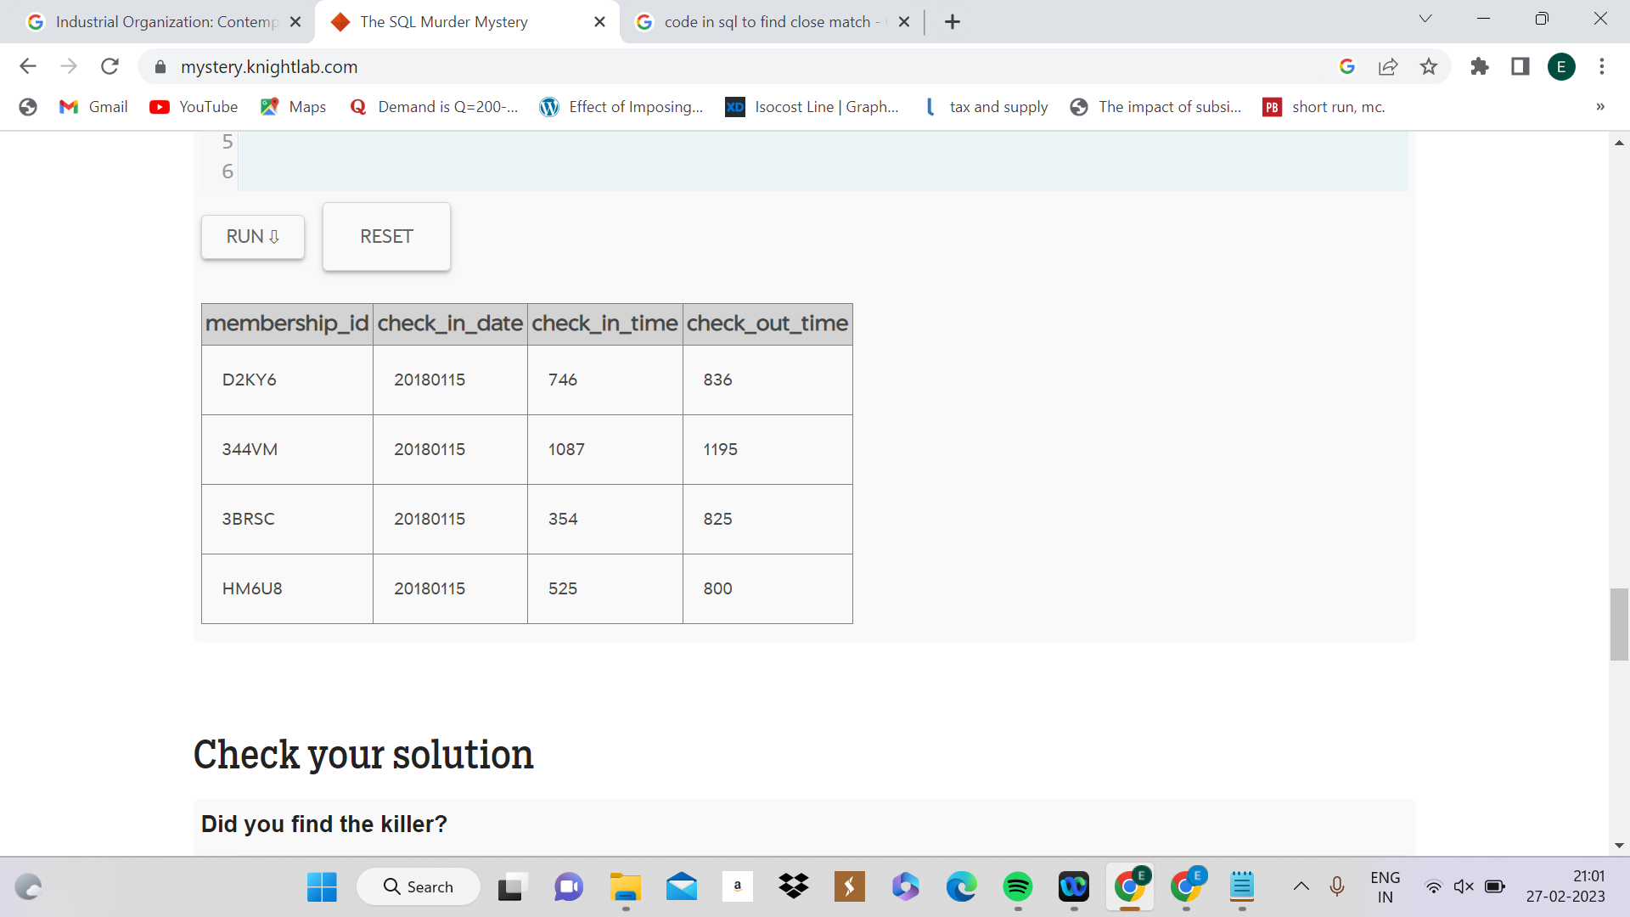

SELECT *

FROM person

WHERE name LIKE 'Annabel%' AND address_street_name = 'Franklin Ave'

| **id** | **name** | **license_id** | **address_number** | **address_street_name** | **ssn** |
| --- | --- | --- | --- | --- | --- |
| 16371 | Annabel Miller | 490173 | 103 | Franklin Ave | 318771143 |

Annabel’s id is **16371**.

1. SELECT *

FROM person

WHERE address_street_name = 'Northwestern Dr'

Order by address_number DESC

| **id** | **name** | **license_id** | **address_number** | **address_street_name** | **ssn** |
| --- | --- | --- | --- | --- | --- |
| 14887 | Morty Schapiro | 118009 | 4919 | Northwestern Dr | 111564949 |
| 17729 | Lasonya Wildey | 439686 | 3824 | Northwestern Dr | 917817122 |
| 53890 | Sophie Tiberio | 957671 | 3755 | Northwestern Dr | 442830147 |
| 73368 | Torie Thalmann | 773862 | 3697 | Northwestern Dr | 341559436 |
| 96595 | Coretta Cubie | 303645 | 3631 | Northwestern Dr | 378403829 |
| 19420 | Cody Schiel | 890431 | 3524 | Northwestern Dr | 947110049 |
| 93509 | Emmitt Aceuedo | 916706 | 3491 | Northwestern Dr | 979073160 |
| 87456 | Leonora Wolfsberger | 215868 | 3483 | Northwestern Dr | 565203106 |
| 36378 | Freddie Ellzey | 267882 | 3449 | Northwestern Dr | 474117596 |
| 53076 | Boris Bijou | 664914 | 3327 | Northwestern Dr | 401191868 |
| 28360 | Rashad Cascone | 924517 | 3212 | Northwestern Dr | 838907424 |
| 23044 | Val Portlock | 924989 | 3143 | Northwestern Dr | 100593316 |
| 51114 | Christena Saffell | 814284 | 3055 | Northwestern Dr | 247657547 |
| 68690 | Yer Modest | 852404 | 3046 | Northwestern Dr | 419238039 |
| 44004 | Alison Eska | 327797 | 2951 | Northwestern Dr | 306417867 |
| 98593 | Jonah Toner | 578982 | 2947 | Northwestern Dr | 745853548 |
| 59307 | Cyril Yongue | 753524 | 2903 | Northwestern Dr | 866057839 |
| 34155 | Allyson Lazenson | 814209 | 2840 | Northwestern Dr | 991150469 |
| 90397 | Dionna Kranwinkle | 797260 | 2678 | Northwestern Dr | 278964807 |
| 54564 | Sammie Sengun | 217286 | 2590 | Northwestern Dr | 848854310 |
| 53699 | Christian Pagano | 628433 | 2585 | Northwestern Dr | 644772304 |
| 34352 | Vincenza Burkhardt | 436470 | 2512 | Northwestern Dr | 197913046 |
| 80921 | Donovan Yackley | 222395 | 2386 | Northwestern Dr | 515049359 |
| 96178 | Galina Khuu | 450248 | 2183 | Northwestern Dr | 398518185 |
| 81885 | Kurtis Masuda | 934201 | 2108 | Northwestern Dr | 201272595 |
| 88423 | Teri Ehrich | 510876 | 1879 | Northwestern Dr | 248637345 |
| 51552 | Bonita Knie | 764124 | 1726 | Northwestern Dr | 597137908 |
| 72076 | Courtney Bordeaux | 324614 | 1707 | Northwestern Dr | 347966356 |
| 81052 | Calvin Czelusniak | 471483 | 1516 | Northwestern Dr | 657531837 |
| 71924 | Laurie Scronce | 774116 | 1418 | Northwestern Dr | 254883636 |
| 23960 | Kristopher Lagerberg | 658777 | 1392 | Northwestern Dr | 492912529 |
| 70485 | Andera Kostelecky | 354822 | 1252 | Northwestern Dr | 787423012 |
| 22239 | Dusty Sigafus | 710517 | 1125 | Northwestern Dr | 724386723 |
| 18376 | Josh Shi | 653712 | 1091 | Northwestern Dr | 193899001 |
| 29608 | Willetta Lurvey | 800568 | 1028 | Northwestern Dr | 843751378 |
| 33415 | Homer Simpson | 108392 | 981 | Northwestern Dr | 871392019 |
| 55130 | Shiloh Huntoon | 472118 | 951 | Northwestern Dr | 826647644 |
| 44542 | Ivory Mcgrevey | 873842 | 897 | Northwestern Dr | 988557407 |
| 99826 | Ivy Kazarian | 994470 | 892 | Northwestern Dr | 208359813 |
| 25615 | Olevia Morena | 388477 | 812 | Northwestern Dr | 962831331 |
| 40760 | Renata Faver | 976650 | 745 | Northwestern Dr | 547572040 |
| 10010 | Muoi Cary | 385336 | 741 | Northwestern Dr | 828638512 |
| 39688 | Abe Roeker | 537445 | 689 | Northwestern Dr | 438969447 |
| 26758 | Angelena Billman | 942074 | 629 | Northwestern Dr | 341854756 |
| 75484 | Del Tacderen | 447887 | 607 | Northwestern Dr | 243821337 |
| 12711 | Norman Apolito | 667757 | 599 | Northwestern Dr | 778264744 |
| 85280 | Donn Duin | 569122 | 540 | Northwestern Dr | 613873810 |
| 40336 | Fredia Billeter | 251082 | 404 | Northwestern Dr | 108056488 |
| 15171 | Weldon Penso | 336999 | 311 | Northwestern Dr | 131379495 |
| 89906 | Kinsey Erickson | 510019 | 309 | Northwestern Dr | 635287661 |

Hence second witness is Morty Schapiro, whose id is **14887**.

1. SELECT *

FROM get_fit_now_member m

JOIN get_fit_now_check_in

ON m.id = membership_id

WHERE check_in_date = '20180109' AND membership_status = 'gold' AND membership_id LIKE '48Z%'

| **id** | **person_id** | **name** | **membership_start_date** | **membership_status** | **membership_id** | **check_in_date** | **check_in_time** | **check_out_time** |
| --- | --- | --- | --- | --- | --- | --- | --- | --- |
| 48Z7A | 28819 | Joe Germuska | 20160305 | gold | 48Z7A | 20180109 | 1600 | 1730 |
| 48Z55 | 67318 | Jeremy Bowers | 20160101 | gold | 48Z55 | 20180109 | 1530 | 1700 |

1. SELECT p.name, d.gender, d.height, d.hair_color, d.car_make, d.car_model

FROM drivers_license as d

JOIN person as p

ON d.id = p.license_id

WHERE gender = 'female' AND d.height BETWEEN 65 AND 67 AND d.hair_color = 'red' AND car_make = 'Tesla' AND car_model = 'Model S'

| **name** | **gender** | **height** | **hair_color** | **car_make** | **car_model** |
| --- | --- | --- | --- | --- | --- |
| Red Korb | female | 65 | red | Tesla | Model S |
| Regina George | female | 66 | red | Tesla | Model S |
| Miranda Priestly | female | 66 | red | Tesla | Model S |

1. SELECT name, address_street_name, address_number, license_id

FROM person

JOIN drivers_license

ON person.license_id = drivers_license.id

WHERE address_street_name = "Franklin Ave" AND

name LIKE "Annabel%"

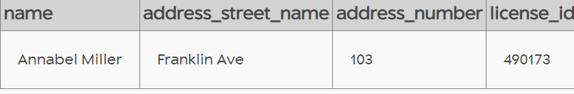

1. SELECT p.name, i.transcript

FROM person p

JOIN interview i

ON p.id = i.person_id

WHERE p.id IN (14887, 16371)

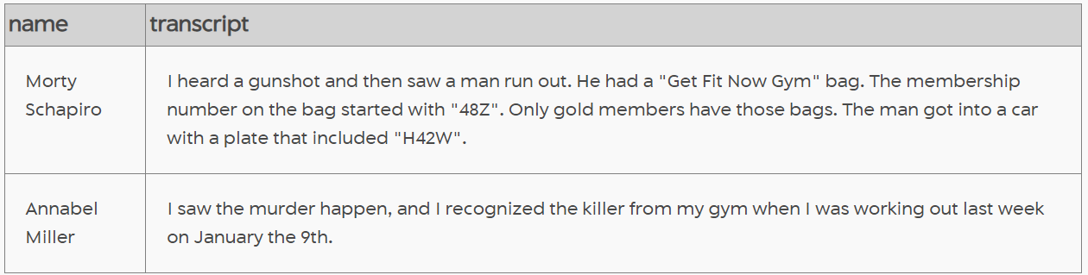

1. SELECT p.name, i.transcript

FROM person p

JOIN interview i

ON p.id = i.person_id

WHERE p.name LIKE '%Jeremy Bowers%'

